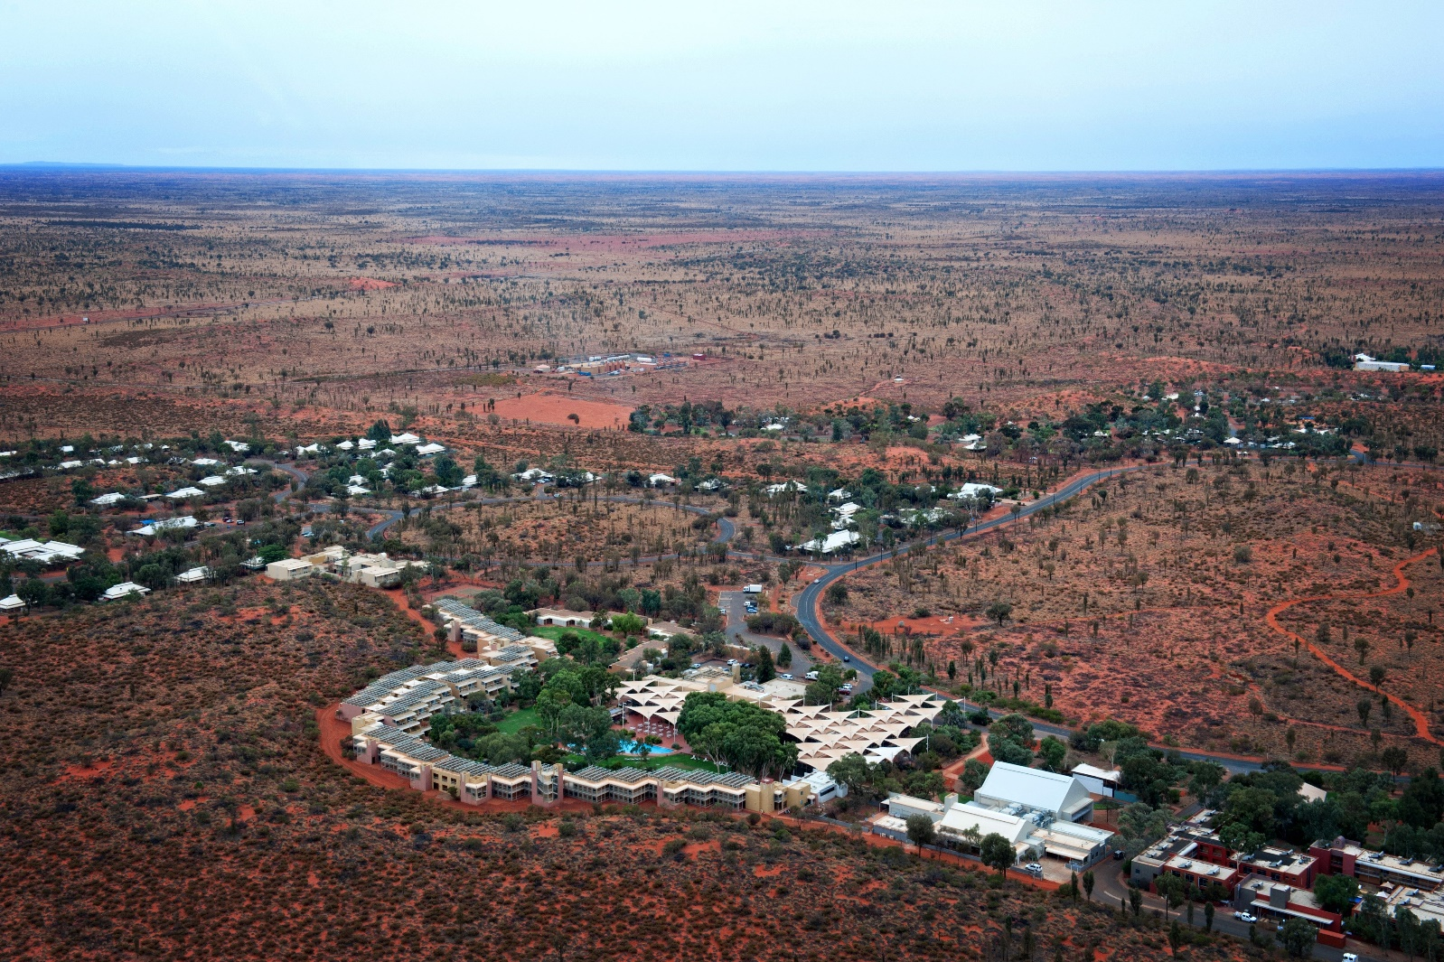
2026
11 Day | Red Centre Tour
Travel to the Australian Outback, a place of rich cultural tradition, vast landscapes and exceptional experiences.

Day 1: (D) HOME TO WAGGA WAGGA 2026
Welcome to our tour to the beating heart of Australia – the Red Centre. We are welcomed on the coach by our friendly crew and begin our journey. This afternoon we arrive in Wagga Wagga where we have time to freshen up before dinner.

Mercure Wagga Wagga | subject to availability
Lunch at own expense | Dinner at motel

Day 2: (BLD) WAGGA WAGGA TO MILDURA 2026
Crossing the Hay Plain, we arrive at Balranald Bakery & Café for lunch. We continue to Mildura for our overnight stay.

Best Western Chaffey Motor Inn, Mildura | subject to availability
Breakfast and dinner at motel | Lunch at Balranald Bakery & Cafe

Day 3: (BLD) MILDURA TO PORT AUGUSTA 2026
Departing Mildura, we head across the South Australian border, travelling through the Riverland region before arriving in Burra, a copper mining town that saved South Australia from bankruptcy in the 1840s. Here we’ll stop to see the “Monster Mine” which was once the largest metal mine in the country employing 1,000 people. Cornish and Welsh miners flocked to Burra to work for the South Australian Mining Association and set up homes in dugouts hewn out of the banks of the Burra River. From here we continue to Port Augusta. Located at the top of the Spencer Gulf, the town was once an important base for arid land explorations to the north and later a busy shipping port.

Standpipe Golf Motor Inn, Port Augusta | subject to availability
Breakfast and dinner at motel | Lunch at Burra Bakery

Day 4: (BLD) PORT AUGUSTA TO COOBER PEDY 2026
After breakfast, our journey takes us to Woomera, known for its long range missile and rocket testing site. As the largest land based range in the world, we delve into the interesting history at the Heritage Centre. After lunch here, the remaining of the afternoon is spent travelling to Coober Pedy – Australia’s opal capital. Beneath the ground, there is a labyrinth of underground houses, hotels and even shops tucked under the earth to escape the extreme heat in summer.

Desert Cave Hotel, Coober Pedy | subject to availability
Breakfast and dinner at motel | Lunch at Woomera Heritage Centre

Day 5: (BD) COOBER PEDY 2026
We are joined by a local guide who will introduce us to Coober Pedy. We are in for an interesting journey as we take a town tour, visit a mine, an underground church, the Big Winch Lookout and Coober Pedy’s Opal Fields Golf Course, the only course in the world with reciprocal rights to Saint Andrews (the home of golf) in Scotland. We have time to purchase lunch before heading to The Breakaways. This reserve consists of spectacular flat topped, colourful mounds that have risen from the desert floor. Dinner tonight will be at John's Pizza Bar & Restaurant.

Desert Cave Hotel, Coober Pedy | subject to availability
Breakfast and dinner at motel | Lunch at own expense

Day 6: (BLD) COOBER PEDY TO ULURU 2026
We have a long travel day as we head across the border into Northern Territory. Look out the window at the seemingly endless horizon where you truly get a sense of how vast this area is. Travelling west from Erldunda through the spinifex and desert oak landscape, Mt Connor will come into view on our left. Continuing to Yulara, the gateway to World Heritage Listed Uluru – Kata Tjuta National Park. Uluru is one of the world’s largest monoliths, towering over the surrounding landscape, rising 348 metres above the desert floor. Not only a spectacular natural rock formation, but a deeply spiritual place and is sacred to the local Anangu people. This evening, we head out to the Sunset viewing area for an experience of a lifetime to watch the changing colours of this magnificent rock as the sun sets. Uluru puts on a remarkable light show as it changes from red to orange to lilac in a matter of minutes. We enjoy this special experience before returning to the resort for dinner.

Voyages Desert Gardens Hotel, Yulara | subject to availability
Breakfast and dinner at motel | Packed lunch included

Day 7: (BD) ULURU 2026
The coach will be ready for an early departure to the Sunrise Viewing Area to experience the first glimpse for the day. After breakfast in the hotel, we return to Uluru to wander the Mala Walk, meander into Mutitjulu Waterhole and discover rock art sites with your guide. You will also venture out to Kata Tjuta also known as The Olgas where the soaring rock domes are an intriguing sight. Tonight, you will be collected for an evening of dining under the sparkling outback sky as you experience Sounds of Silence. The romance of the desert, the setting of the sun, the haunting sounds of the didgeridoo, scrumptious outback fare and the star filled sky – this is the best of the Red Centre distilled into four magical hours. The experience begins with canapes and sparkling wine upon a dune top overlooking the national park as the didgeridoo player weaves their magic spell. Following a bush tucker inspired dinner incorporating native ingredients, you are treated to some incredible stargazing as a resident star talker decodes the night sky.

Voyages Desert Gardens Hotel, Yulara | subject to availability
Breakfast at motel | Lunch at own expense | Dinner on tour

Day 8: (BLD) ULURU TO KINGS CANYON 2026
After a leisurely breakfast, we travel towards Kings Canyon, a majestic destination featuring 100 metre high sandstone walls, palm filled crevices and views that stretch across the desert. We have lunch at Kings Creek Station before delving into the Karrke Aboriginal Cultural Experience, a journey into the survival techniques of indigenous ancestors across these desert conditions. Lead by community members, we will unravel the deep rooted connection to the land by showcasing their tools, musical instruments, bush tucker, medicinal plans and the evolution of the local languages. This evening, we enjoy nibbles and drinks at the incredible Luritja Lookout. Spectacular hues of red, orange, purple and pink are filtered through the Red Centre’s unique sandy surrounds, before millions of stars come out to play. We then venue to the Light Towers, an immersive sound and light installation by acclaimed international artist Bruce Munro. Wander through the 69 two metre towers made up of 216 glass bottles per tower that change colour as an entrancing soundscape by composer Orlando Gough plays, taking us on a captivating and immersive auditory and visual journey.

Discovery Resorts - Kings Canyon | subject to availability
Breakfast and dinner at motel | Lunch at Kings Creek Station
Karrke available Wed-Fri only

Day 9: (BLD) KINGS CANYON TO ALICE SPRINGS 2026
This morning, we have the chance to enjoy the 2 kilometre Creek Bed Walk. Admire the soaring canyon walls and incredible flora and fauna of the canyon before reaching the lookout point which offers spectacular views of the sheer cliff faces at the far end of the canyon. This afternoon we travel to Alice Springs, the thriving and spirited outback centre.

Crowne Plaza Alice Springs Lasseters | subject to availability
Breakfast and dinner at motel | Lunch at Erldunda Desert Oaks Resort

Please note a reasonable level of fitness is required to do any walks in Kings Canyon, it is up to the individual passenger to decide if these walks are suitable for their fitness level.

Day 10: (BLD) ALICE SPRINGS 2026
Today we uncover the highlights of Alice Springs. We take a look at School of the Air, a service dedicated to educating students in remote areas. Next, visit the Old Telegraph Station, and the original Alice Springs. With incredible indoor and outdoor displays, the story of the connection of Australia and the rest of the world through telegraph communication unfolds. We then visit the Royal Flying Doctor Service (RFDS). We hear the incredible history of one of the largest and most comprehensive aeromedical organisations in the world. Using the latest aviation, medical and communication technology, the RFDS delivers extensive primary healthcare and 24 hour emergency service to those who live, work and travel throughout remote Australia. Tonight, we head to Earth Sanctuary – a World Nature Centre at Quandong Homestead to enjoy a mouth-watering bush BBQ. We will be treated to music, entertainment and experience the spirit of the outback through stories of local ecology, culture and astronomy. What an incredible day!

Crowne Plaza Alice Springs Lasseters | subject to availability
Breakfast and dinner at motel | Lunch at Base Cafe

Day 11: (B) ALICE SPRINGS TO HOME 2026
After travelling to some of the most fascinating outback destinations and iconic Australian landmarks, we have a travel day home. We are transferred to our flight from Alice Springs to Sydney, arriving home from an incredible tour.

Breakfast at motel | Lunch at own expense

All itineraries are subject to change due to occasional restrictions in opening times/days of some attractions. We cannot be held responsible for any changes due to closures, inclement weather etc. This itinerary is going through a National Park. Please check if you require an Operator’s Licence to enter the park.
Itinerary #1 | 08.09.25 | MM

