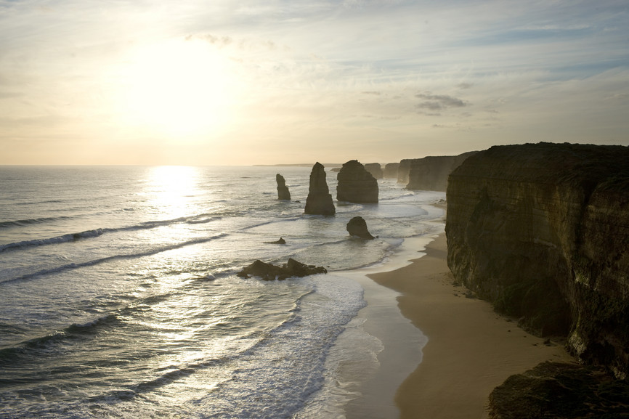
March 2026
7 Day | Great Ocean Road Tour
Tick the Great Ocean Road off your travel bucket list.

Day 1: (D) HOME TO WAGGA WAGGA 2026
Welcome to our wonderful tour to the Great Ocean Road. We meet our friendly crew and fellow travellers as we begin our tour. We have a travel day ahead as we stop for convenience breaks and to purchase lunch before arriving at Wagga Wagga for our overnight stay.

Mercure Wagga Wagga | subject to availability
Lunch at own expense | Dinner at motel

Day 2: (BLD) WAGGA WAGGA TO GEELONG 2026
We continue south, travelling across the Victorian state border. Travelling to Seymour, we enjoy lunch at The Brewer's Table before taking some time to view the Vietnam Veterans Commemorative Walk, built to commemorate the service of all those who played their part in what turned out to be a tumultuous part of Australia’s history. Our destination today is Geelong, situated on Corio Bay, an arm of Port Phillip Bay and is Victoria’s most sizable provincial city. Despite Geelong’s industrial reputation, the CBD is quite elegant and beautiful due to the Victorian public architecture, floral gardens, parklands and seaside location.

Rydges Geelong | subject to availability
Breakfast and dinner at motel | Lunch at The Brewer's Table

Day 3: (BLD) Q TRAIN 2026
This morning, we make our way to Drysdale Railway Station to board The Q Train. The dining journey includes an exceptional degustation of fresh local produce, all cooked and prepared on board in the well-appointed kitchen car. Every day, the Head Chef and their team carefully choose top quality ingredients from local, ethical and sustainable producers. This way the menu always reflects the very best of what the region has to offer – so expect fresh, delicious and seasonally changing menus. As the train whistle sounds the journey begins, travelling along the beautiful Bellarine Railway, offering views of the rolling hills of The Bellarine. The Q Train will pause at Queenscliff and/or Suma Park Station, where we encourage you to stretch your legs. The journey continues travelling alongside beautiful Swan Bay where these protected wetlands are abundant with birdlife. The Q Train returns to Drysdale Station three hours after departure, with memories of a dining journey you won’t soon forget. We complete the day with a wine tasting at Jack Rabbit Vineyard with stunning views over the vineyards and bay and on a clear day you can see as far as the You Yangs and Melbourne city skyscrapers.

Rydges Geelong | subject to availability
Breakfast and dinner at motel | Lunch included on Q Train
Q Train available Monday, Thursday, Friday and Sunday only

Day 4: (BD) GREAT OCEAN ROAD 2026
Today we travel along one Australia’s most spectacular coastal roads, the Great Ocean Road. The coastline, although extremely dangerous for the early sailors, is spectacular. We make our way south to Torquay which begins our drive along the Great Ocean Road. Our morning stop will be at the popular Victorian seaside village of Lorne, where we will have time to wander the township. From Lorne we travel onto Apollo Bay, where the road leaves the coast and winds through the slopes of the Otway Ranges and Otway National Park. To the west of the Otway Ranges the Great Ocean Road rejoins the coast and runs the full length of the Port Campbell National Park. The Great Ocean Road offers some of the most dramatic coastal scenery in Australia and the stretch on either side of the town of Port Campbell is the most exciting part! We pass Loch Ard Gorge, which has a sad tale to tell. In 1878 the iron hulled clipper Loch Ard was driven out onto rocks offshore at this point. Of the 50 or so on board only two were to survive, being swept into the narrow gorge named after their ill-fated vessel. It’s here we also see the Twelve Apostles - huge pillars that loom out of the surf, carved over time by the fury of the ocean. Beyond Port Campbell we come to London Bridge. This was once a famous landmark and a bridge-like promontory arching across a furious sea. However, in 1990 it collapsed dramatically into the sea, stranding a handful of amazed (and extremely lucky) visitors at the far end! Soon after the Great Ocean Road veers somewhat away from the coast and heads towards Warrnambool, a beautiful seaside city on the shores of Lady Bay. More than 100 ships and boats were wrecked within 80 kilometres from Warrnambool, hence the current name for the area - The Shipwreck Coast.

Mid City Motel Warrnambool | subject to availability
Breakfast and dinner at motel | Lunch at own expense

Day 5: (BLD) WARRNAMBOOL 2026
A local guide will join the coach this morning as we embark on a sightseeing tour of the town where we will see and hear about the rich maritime history and the final resting place of over 180 wrecks. We then head out of town to visit Tower Hill Wildlife Reserve. The 614 hectare reserve is situated in the crater of an extinct volcano which formed thousands of years ago when a violent eruption created the funnel-shaped crater which was later filled by the lake. The reserve is home to many native Australian animals, such as kangaroos, koalas, wombats and some very bold emus! We’ll drive through the reserve via a one way scenic road, over a land bridge to the main body of land which is virtually surrounded by Tower Hill Lake. We return to Warrnambool for time to purchase lunch (own expense) before our afternoon visit to the Flagstaff Hill Maritime Village. Supported by the local community this delightful complex authentically recreates the appearance, atmosphere and activities apparent in a small coastal port during the 50 years prior to 1900. It presents and preserves material, artefacts and vessels relating to Australia’s early maritime museum. After dinner in our motel, we have arranged to see the spectacular “Shipwrecked” sound and laser show at the Flagstaff Hill Maritime Museum. The show recreates the tragic story of the Loch Ard Shipwreck that took place in local waters more than 120 years ago.

Mid City Motel Warrnambool | subject to availability
Breakfast and dinner at motel | Lunch at Flagstaff Hill Maritime Village

Day 6: (BD) WARRNAMBOOL TO ALBURY 2026
We have a travel day ahead as we make our way to Albury. Watch the scenery roll by your window, chat with new friends of finish your book as we arrive in Albury for our final night on tour together.

Quality Resort Siesta, Albury | subject to availability
Breakfast and dinner at motel | Lunch at own expense

Day 7: (BL) ALBURY TO HOME 2026
With our bags packed, we load the coach and make our way home. We enjoy our farewell lunch in Goulburn before continuing home from a wonderful tour.

Breakfast at motel | Lunch at Paragon Cafe

All itineraries are subject to change due to occasional restrictions in opening times/days of some attractions. We cannot be held responsible for any changes due to closures, inclement weather etc. This itinerary is going through a National Park. Please check if you require an Operator’s Licence to enter the park.
Itinerary #1 | 08.09.25 | MM

