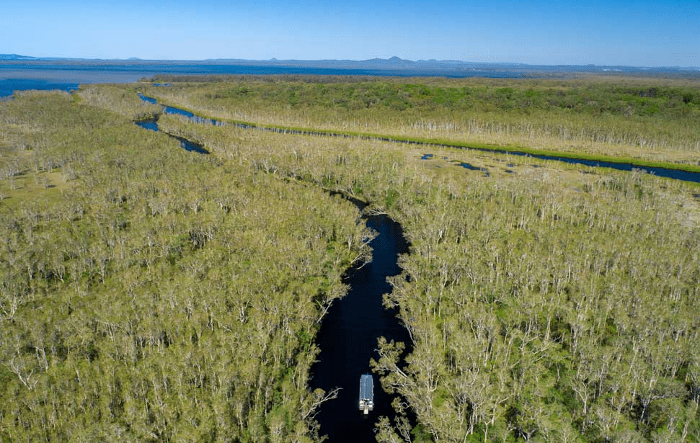
June 2026
7 Day | Sunshine Coast Tour
Travel to the Sunshine Coast where pristine beaches sit alongside subtropical rainforest and majestic mountains.

Day 1: (D) HOME TO ARMIDALE 2026
Welcome to our wonderful tour to the Sunshine Coast. Meeting our fellow travellers and friendly crew, we begin our tour. Our destination today is Armidale, one of the most elegant regional cities.

Country Comfort Armidale | subject to availability
Lunch at own expense | Dinner at motel

Day 2: (BLD) ARMIDALE TO SUNSHINE COAST 2026
We have another day on the road, travelling through the picturesque New England region across the Queensland border to Stanthorpe. Lunch will be served at Sutton's Juice Factory & Cidery, where you’ll discover a myriad of products crafted from the humble apple. Based on a real working orchard, David and Ros Sutton began in 1994 after owning two previous businesses – firstly a grain and livestock property and then a prawn trawler in North Queensland. Once the skill of orcharding was mastered they began production of the varietal apple juice and apple cider. From these two products the range of handcrafted creations has grown to include apple brandy, fruit liqueurs, apple cider vinegar, apple syrup and a wide range of preserves. From here we continue to the Sunshine Coast. Our resort is located in scenic Caloundra. Dinner will be served in the restaurant with a beautiful setting overlooking the lagoon.

Oaks Sunshine Coast Oasis Resort | subject to availability
Breakfast and dinner at motel | Lunch at Sutton’s Juice Factory & Cidery

Day 3: (BLD) NOOSA EVERGLADES 2026
Today we board our purpose built vessel for a cruise along the pristine Noosa River and into the dark, tranquil and mirrored waterways of the Noosa Everglades. Cruise upstream through ancient landscapes and subtropical rainforest, on a river system which has its entire upper catchment protected by National Park. Having worked up an appetite, enjoy morning tea at the historic loggers camp, Harry’s Hut, a relic of the early timber cutting days and a delicious lunch overlooking the lake and parklands at Coothara Bar. Following this incredible experience, we spend some time in the popular Hastings Street section of Noosa where you can look through the various stores before returning to Caloundra.

Oaks Sunshine Coast Oasis Resort | subject to availability
Breakfast and dinner at motel | Lunch included on tour

Day 4: (BLD) EUMUNDI MARKETS AND GINGER FACTORY Wed/Sat 2026
Today we head off to famous Eumundi Markets. On market day, this sleepy town transforms into a vibrant mecca for shoppers looking for something different. We step into a world of original design of jewellery, homewares, clothing and artwork. Take a break from shopping and grab yourself a gourmet delight of listen to one of the entertaining buskers. There’s certainly something for everyone here. Late morning, we make our way to Yandina to visit The Ginger Factory. We enjoy lunch here then it’s all about Ginger as we are guided through the ginger story. Packed full of nutrients, ginger purportedly relieves morning and motion sickness. We’ll learn how it’s grown, harvested and processed and take a tour through lush subtropical gardens on the beloved history train, Moreton. Now over 100 years old, Moreton was a sugar cane train working at the Moreton Sugar Mill in Nambour and now spends his days taking visitors through the Ginger Factory grounds. We finish our tour with delicious tastings.

Oaks Sunshine Coast Oasis Resort | subject to availability
Breakfast and dinner at motel | Lunch at the Ginger Factory

Day 5: (BLD) SUNSHINE COAST HINTERLAND 2026
We have a fabulous day in store as we travel up to The Blackall Range. Our first stop of the day is a guided tour of Mary Cairncross Scenic Reserve on the southern edge of the Blackall Range, overlooking the unique formations of the spectacular Glasshouse Mountains. We have a special lunch at Secrets on the Lake, situation in the rainforest on the shores of Lake Baroon with panoramic views of the water, mountains and rainforest. From here we make our way north along the range taking in the beautiful vistas along the way to Montville. Step back in time and enjoy the tranquillity of village life in a streetscape unique to any other tourist centre in Australia. We will have free time to browse the many arts and craft shops. At the northern end of the Range, we stop at Dulong Lookout for the last of the breathtaking views out to the coastline.

Oaks Sunshine Coast Oasis Resort | subject to availability
Breakfast and dinner at motel | Lunch at Secrets on the Lake

Day 6: (BD) SUNSHINE COAST TO COFFS HARBOUR 2026
We say goodbye to the Sunshine Coast, travelling home via the coast. Today is a travel day as we stop for lunch (own expense) before continuing to Coffs Harbour. Enjoy our farewell dinner in the onsite restaurant.

Opal Cove Resort, Coffs Harbour | subject to availability
Breakfast and dinner at motel | Lunch at own expense

Day 7: (B) COFFS HARBOUR TO HOME 2026
With our bags packed full of wonderful memories its time to head for home. We return with incredible memories of our getaway with new friends.

Breakfast at motel | Lunch at own expense

All itineraries are subject to change due to occasional restrictions in opening times/days of some attractions. We cannot be held responsible for any changes due to closures, inclement weather etc. This itinerary is going through a National Park. Please check if you require an Operator’s Licence to enter the park.
Itinerary #1 | 09.09.25 | MM

